Bahria University,

Karachi Campus



LAB EXPERIMENT NO.

**05**

LIST OF TASKS

|  |  |
| --- | --- |
| TASK NO | OBJECTIVE |
| **1** | **MVC API with post man validation** |
|  |  |

**Task 1: Implement Car Stock system and search car data by car id using web API.**

**Solution:**

**Car Details Controller Code:**

namespace MVC_API.Controllers{

public class CarDetailsController : ApiController {

// GET: api/CarDetails

public IEnumerable<CarStock> GetAllcarDetails() {

CarStock st = new CarStock();

CarStock st1 = new CarStock();

List<CarStock> li = new List<CarStock>();

st.CarName = "Audi";

st.CarPrice = "10 lakh";

st.CarModel = "A 8";

st.CarColor = "blue";

st1.CarName = "BMW";

st1.CarPrice = "1 crore";

st1.CarModel = "22";

st1.CarColor = "Black";

li.Add(st);

li.Add(st1);

return li;}

public IEnumerable<CarStock> Get(int id){

CarStock st = new CarStock();

CarStock st1 = new CarStock();

List<CarStock> li = new List<CarStock>();

if (id == 1){

st.CarName = "Audi";

st.CarPrice = "10 lakh";

st.CarModel = "A 8";

st.CarColor = "blue";

li.Add(st);}

else{

st1.CarName = "BMW";

st1.CarPrice = "1 crore";

st1.CarModel = "22";

st1.CarColor = "Black";

li.Add(st1);}

return li; }

[HttpPost]

public void Post([FromBody]CarStock cs) {}

[HttpPut]

public void Put(int id, [FromBody]CarStock cs){}

[HttpDelete]

public void Delete(int id){}}}

**Car Controller Code:**

namespace MVC_API.Controllers{

public class CarController : Controller{

public ActionResult GetCar(){

return View("CarStock");}}}

**View Code:**

@{

ViewBag.Title = "CarStock";

}

<h2>CarStock</h2>

<script src="~/Scripts/jquery-3.3.1.min.js"></script>

<script lang="ja" type="text/javascript">

function AllCarDetails() {

$.ajax({

type: "GET",

url="http://localhost:54139/api/CarDetails",

dataType: "json",

success: function (data) {

debugger;

var datadatavalue = data;

var myJsonObject = datavalue;

contentType: "application/json";

$.each(myJsonObject, function (i, mobj) {

$("#Cartbl").append('<tr><td width="50px">' + mobj.CarName +

'</td><td width="50px">' + mobj.CarModel +

'</td><td width="50px">' + mobj.CarPrice +

'</td>' + '</td><td width="50px">'

+ mobj.CarColor + '</td></tr>');});};

error: function (xhr) {

alert(xhr.responseText)});}

function PostData() {

var cardetails = {

CarName: "Audi",

CarModel: "A 8",

CarPrice: "10 lAKHS",

CarColor: "blue" };

$.ajax({

type: "POST",

data: JSON.stringify(cardetails),

url: "http://localhost:54139/api/CarDetails",

dataType: "json",

contentType: "application/json",

});}

function PutData() {

var cardetails ={

CarName: "Audi",

CarModel: "A 8",

CarPrice: "10 lAKHS",

CarColor: "blue"};

var t = JSON.stringify(cardetails);

var id = "0";

$.ajax({

url: 'http://localhost:54139/api/CarDetails/' + id,

type: "put",

contentType: "application/json; charset=utf-8",

data: t,

dataType: "json",

});

function deleteData1(){

var id = 0;

$.ajax({

url: 'http://localhost:54139/api/CarDetails/' + id,

type: 'DELETE',

success: function(data) },

error: function(data) {

alert('Problem Occur in deleting Car:' + data.responseText);

}});}

function GetCarById() {

var id = 1;

$.ajax({

url: 'http://localhost:54139/api/CarDetails/' + id,

type: 'GET',

dataType: "json",

success: function(data) {

var datavalue = data;

var myJsonObject = datavalue;

var CarModel = myJsonObject[0].CarModel;

var CarName = myJsonObject[0].CarName;

var CarColor = myJsonObject[0].CarColor;

var CarPrice = myJsonObject[0].CarPrice;

$('<tr><td>' + CarModel + '</td><td>' + CarName +

'</td><td>' + CarColor + '</td>' + '</td><td>' + CarPrice + '</td></tr>')

.appendTo('#Cartbl');

},

error: function(xhr) {

alert(xhr.responseText);}}

</script>

@using (Html.BeginForm()){

<div style="text-align:center;">

<table border="1" width="70%" style="color:chocolate" id="Cartbl">

<tr>

<td>

<input id="btnget" type="button" onclick="AllCarDetails();" value="Get_Data" />

<input id="btngetbyid" type="button" onclick="GetCarById();" value="Get_ByID" />

<input id="btnpost" type="button" onclick="PostData();" value="Post_Data" />

<input id="btnput" type="button" onclick="PutData();" value="Put_Data" />

<input id="btnDelete" type="button" onclick="deleteData1();" value="Delete_Data" />

</td>

</tr>

</table>

</div>}

**Car Stock Class Code:**

namespace MVC_API{

public class CarStock{

public string CarName { get; set; }

public string CarModel { get; set; }

public string CarPrice { get; set; }

public string CarColor { get; set; }}}

**Output:**

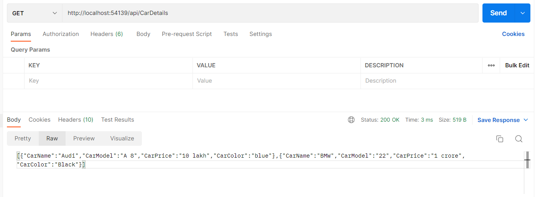

**Search By Id :**

